**Design:**

When it comes to the way the code works, using a flowchart is a great starting point to help determine what process needs to be followed. In this case, the below flowchart is a visual representation of how the form should work.

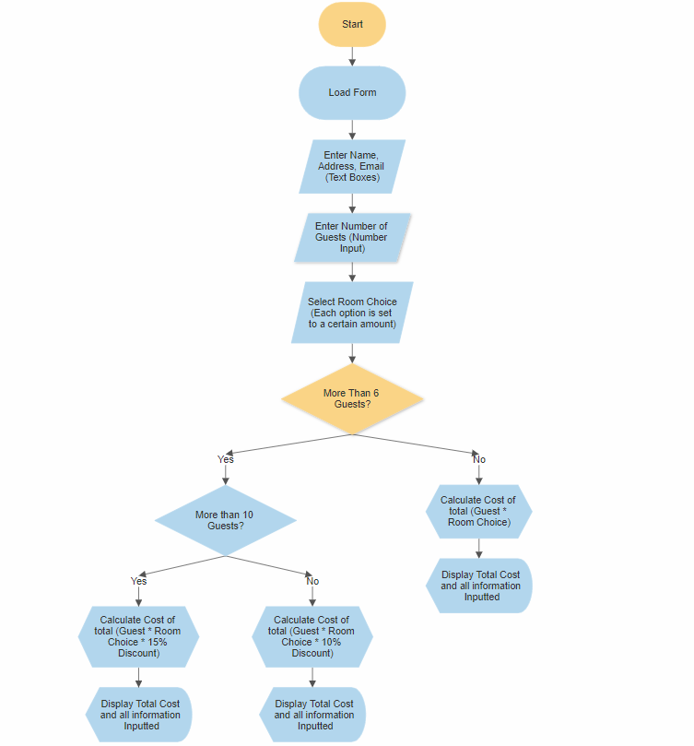

When the user enters the information, it should calculate within the code the total cost of the booking as well as feeding back a summary of all the information entered. The total cost is calculated by setting the room choice options to individual prices and having an ‘if’ statement to determine if the user qualifies for discount depending on what number of guests will be staying at the hotel.

The data will be input as follows:

**Title – Dropdown Box**

**Name – Text Box**

**Address – Text Box**

**Email – Text Box**

**Name of Hotel – Dropdown Box**

**Type of Room – Dropdown Box**

**Number of Guests – Number Input**

**Type of Meal – Dropdown Box**

**Payment Method – Dropdown Box**

When the user submits information, it will feedback and print into the summary section at the bottom of the page.

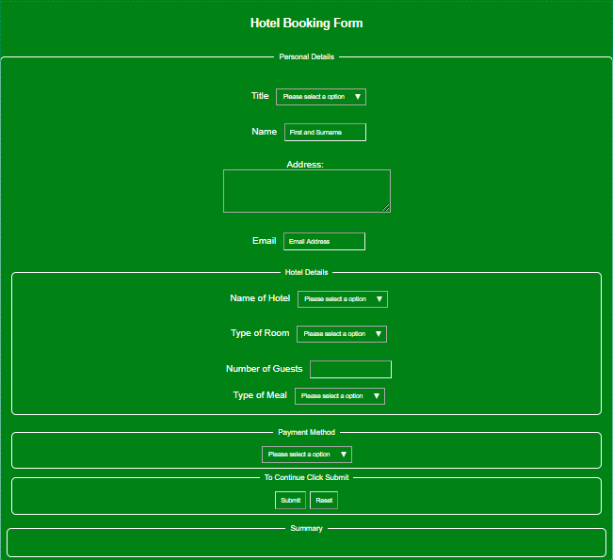The form will look like this:

The Submitted information will print like this:

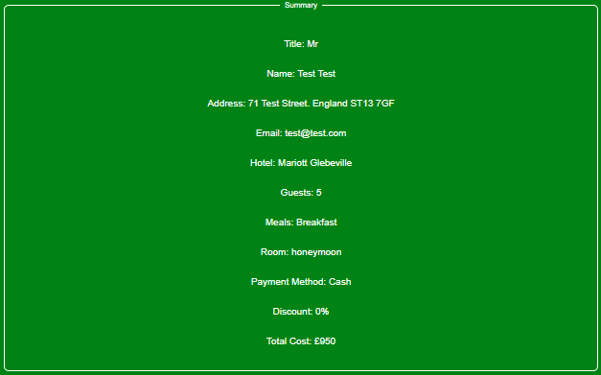

**Testing:**

Testing is vital to make sure a program works, in this case ways to test would be to alter the choice of room to make sure the price changes accordingly and alter the number of guests to make sure the discount if statement works.

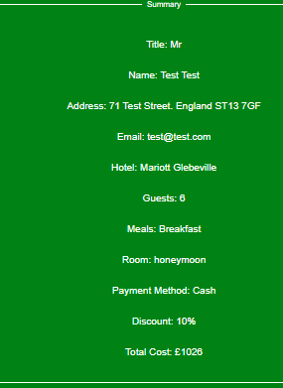

Inputting more than 6 guests to apply 10% discount:

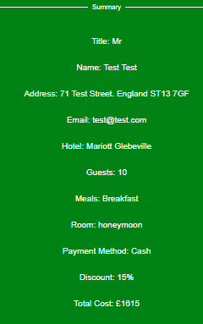

Inputting more than 10 guests apply 15% discount:

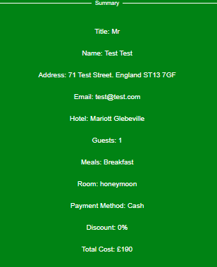

Honeymoon Room Choice:

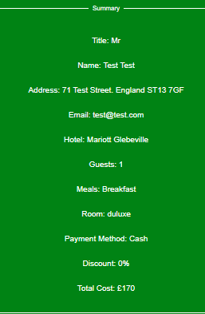Duluxe Room Choice:

Double Room Choice: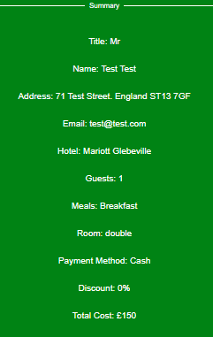

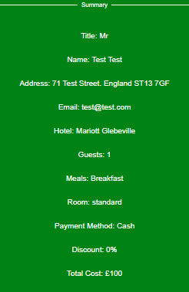Standard Room Choice: